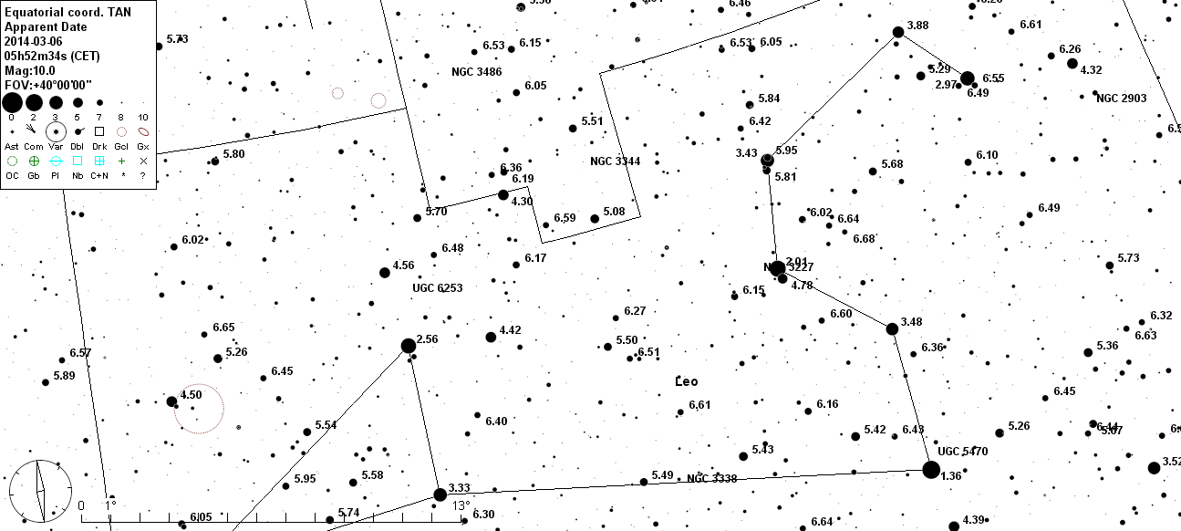
NGC 3185. Galax i Leo. Mag: 12,2. 2,1x1,4 RA: 10h18m 19.9s +21.36' 59"

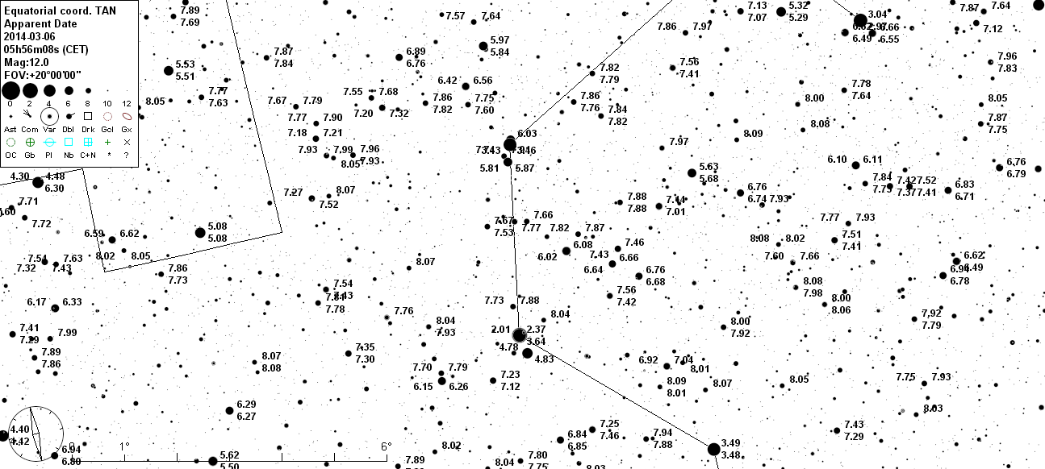

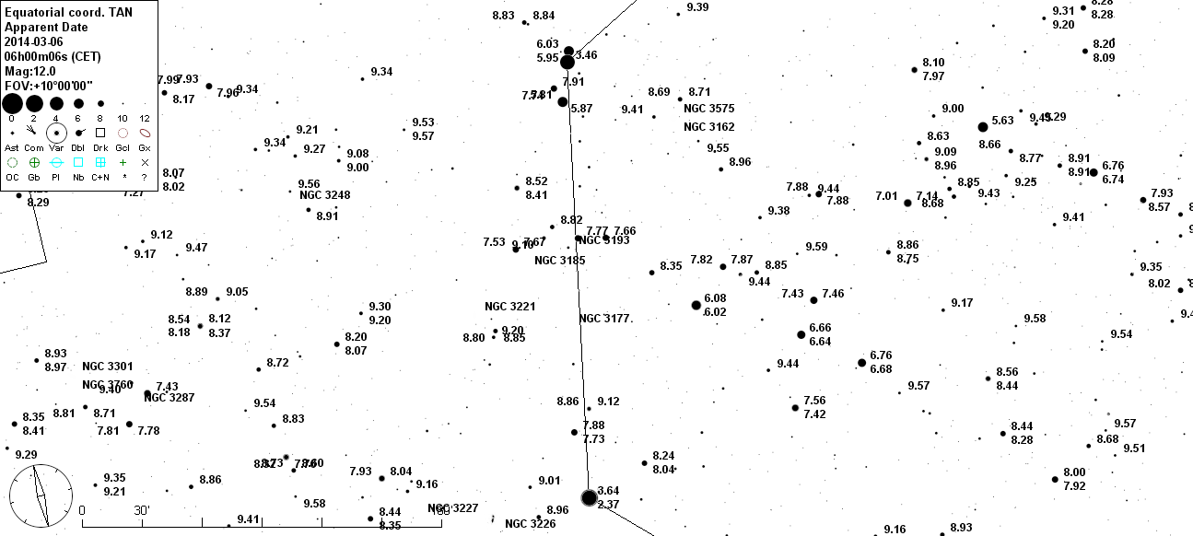

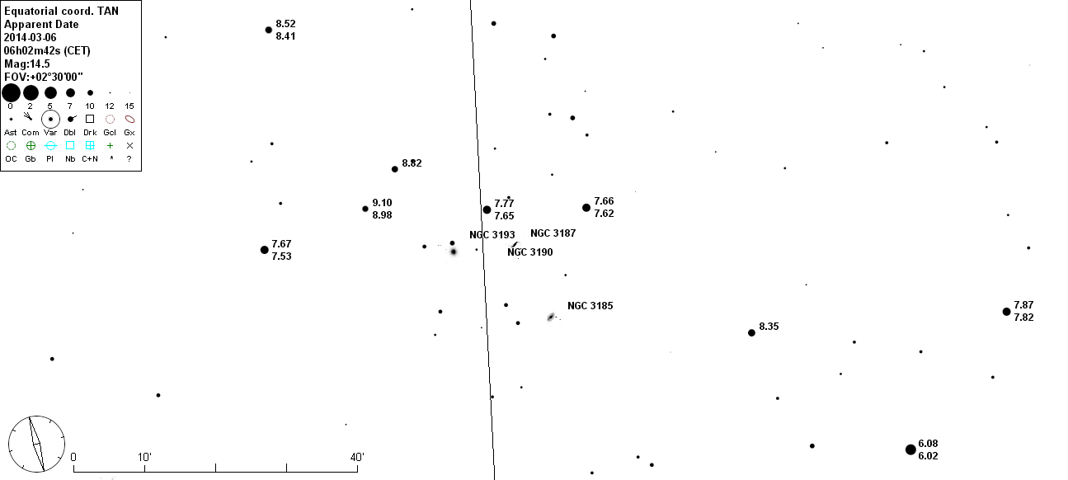
HCG 44. Galaxer i Leo. Mag:12,2. RA: 10h18m 19.9s +21.36' 59"

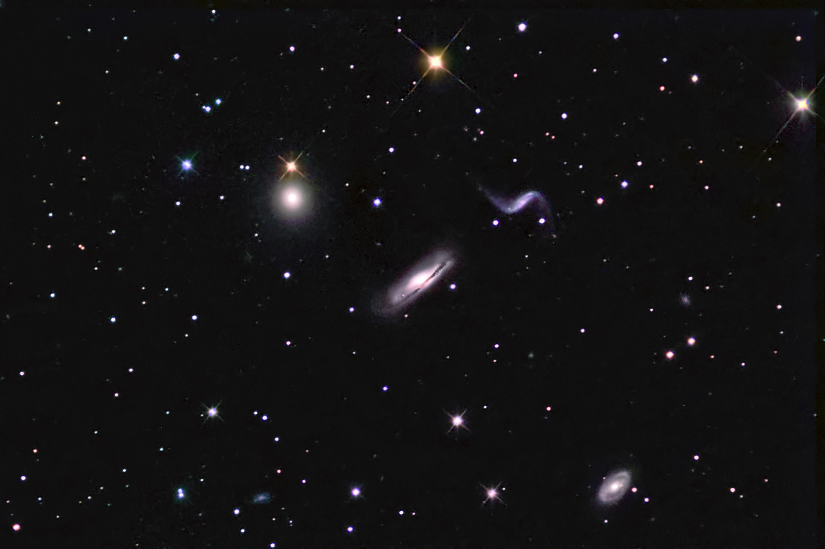

3187
3193

3190

3185

Hicksongrupp nr 44
In 1982 Paul Hickson published a catalog of 462 galaxies considered to exist in compact groupings. These groupings are now known as Hickson Compact Groups. These compact groups are typically composed of four to five closely associated galaxies. These galaxies are thought to be in the process of merging with the final result being a large elliptical galaxy. The Hickson Compact Groups represent a cross section of the various stages of close galactic interactions and therefore is a classic study of the evolution of galactic mergers and eventual formation of large elliptical galaxy structures.
Hickson Compact Groups #44 (HCG #44) lies in the constellation Leo approximately 100 million light-years distant. It is composed of 4 dominant galaxies, NGC 3190, 3193, 2185 and 3187. An image with the galaxies labeled may be viewed here. The large spiral galaxy in the center of the image and the smaller galaxy to its upper right show a large amount of distortion in their structure. This is most likely due to mutual gravitational interaction and is just a beginning stage of their eventual merger.

