Nova Delphi 2013, 23 aug 2013.
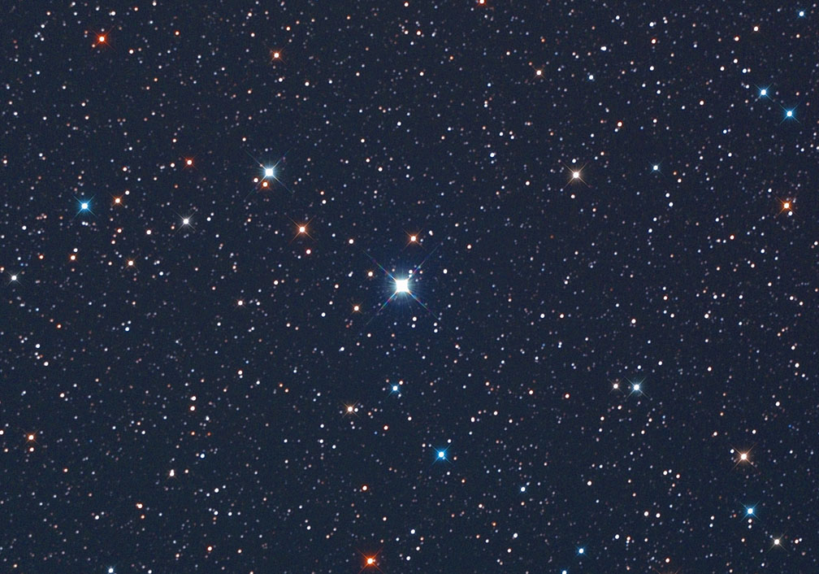
Mag: 11,38-4,4->…. RA: 20h23m58.133s Dec +20.48´12.62”

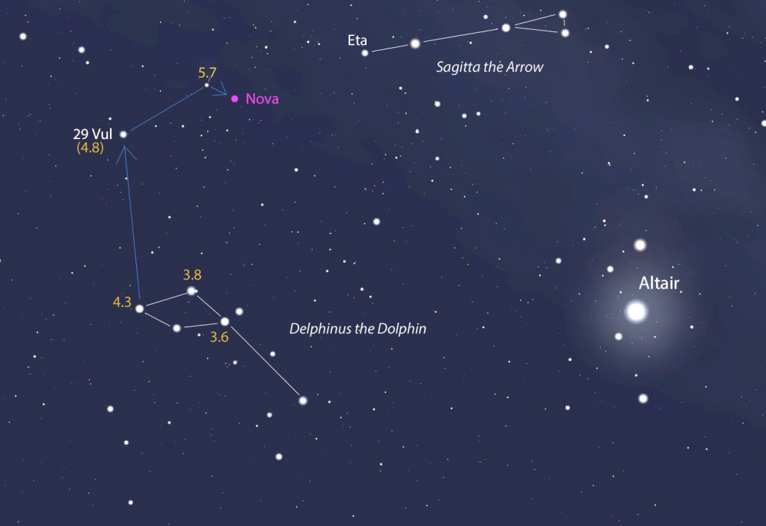

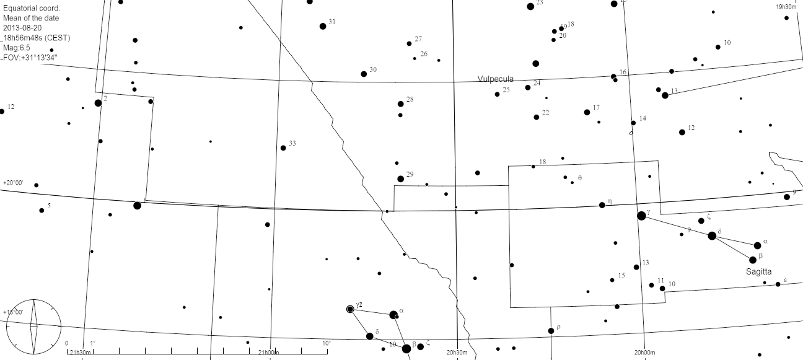

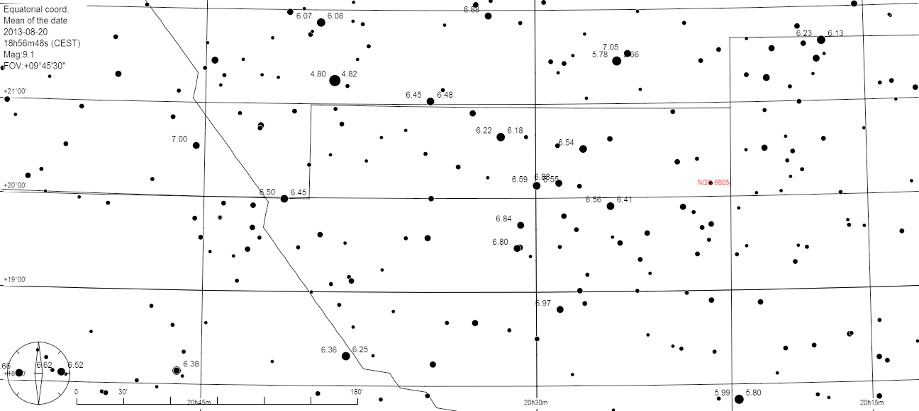

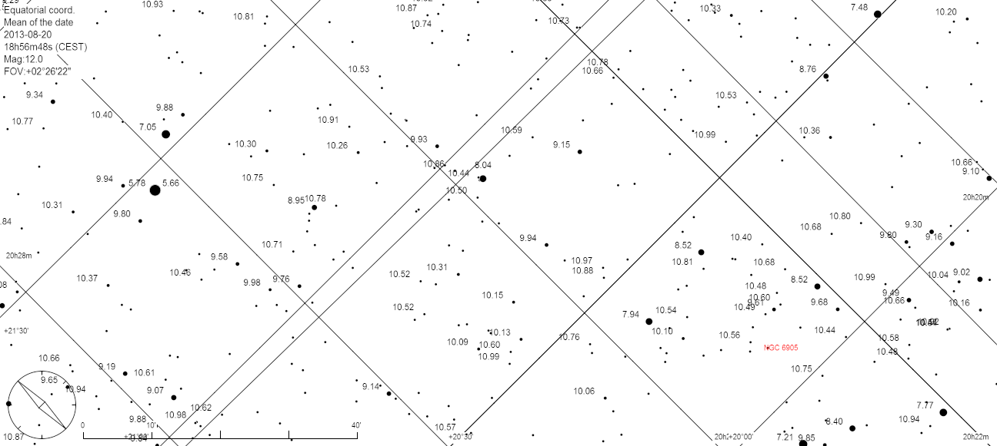

It’s official. The new nova has been christened Nova Delphini 2013. Even better, it’s brightened since discovery. Last night a group of stargazers and I saw the pale yellow star with ease through the telescope. Later, when the moon had set, I was even able to spot the nova faintly with the naked eye at magnitude 5.8.
It’s been years since we’ve had an exploding star of this variety reach naked eye brightness. About 6-10 novae are discovered each year, most of them needing at least a small telescope to see. This year novae have popped off in Cepheus, Scorpius and possibly one in Aquila. Amateur astronomers are the nova finders, training cameras on swaths of the Milky Way night after night hoping to catch one in outburst.
The brightest nova ever recorded blew its top in Aquila the Eagle in 1918. V603 Aquilae shot all the up to -1.4 magnitude or nearly as bright as Sirius, the brightest star. You can still see it today in a 6-inch or larger telescope biding its time around magnitude 12 patiently waiting for another chance at nova-hood. Click HERE to get a finder chart.
- See more at: http://astrobob.areavoices.com/2013/08/15/nova-delphini-2013-a-white-dwarf-with-a-yearn-to-burn/#sthash.p8bXObOx.dpuf

